TASK ON RDS – 16/09/2026

- Create MariaDB DB on EC2.

Objective
To install and configure MariaDB on an Amazon EC2 instance.

AWS Resources Created

VPC
- VPC Name: RDS-Lab-VPC
- CIDR: 10.0.0.0/16
- Region: US East (N. Virginia) — us-east-1

Internet Gateway
- Name: RDS-Lab-IGW
- Attached to RDS-Lab-VPC

Public Subnets
Subnet | CIDR | Availability Zone
RDS-Lab-Public-Subnet-1 | 10.0.1.0/24 | us-east-1a
RDS-Lab-Public-Subnet-2 | 10.0.2.0/24 | us-east-1b

Route Table
- Name: RDS-Lab-Public-RT
- Associated with both public subnets.
- Added an internet route:
Destination: 0.0.0.0/0
Target: RDS-Lab-IGW

EC2 Instance
- Name: RDS-Lab-MariaDB-EC2
- AMI: Amazon Linux 2023
- Instance Type: t3.micro
- Subnet: RDS-Lab-Public-Subnet-1
- Public IP: Enabled
- Security Group: RDS-Lab-EC2-SG
- Inbound: SSH (22) from My IP

MariaDB Installation
Connected to the EC2 instance using SSH:
ssh -i IAM_EBS_KEY.pem ec2-user@<EC2-Public-IP>
Updated the system:
sudo dnf update -y
Installed MariaDB 12.3:
sudo dnf install mariadb123-server -y
Started the MariaDB service:
sudo systemctl start mariadb
Enabled MariaDB to start automatically after system reboot:
sudo systemctl enable mariadb
Verified that MariaDB was running:
sudo systemctl status mariadb
The service showed:
Active: active (running)
Connected to MariaDB:
sudo mariadb
Verified the MariaDB version:
SELECT VERSION();
The installed MariaDB version was 12.3.

Result
Successfully installed, started, configured, and verified MariaDB 12.3 on an Amazon EC2 instance.

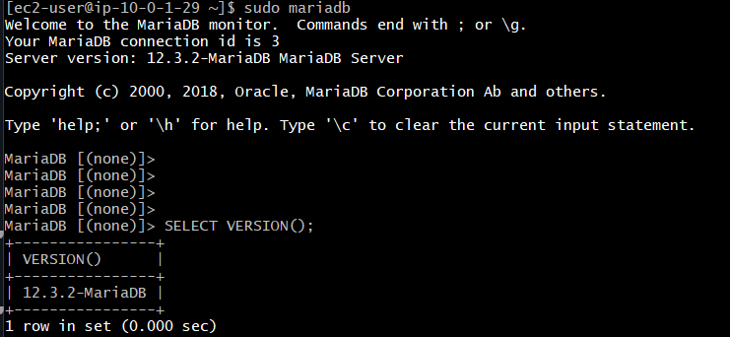
- Insert some dummy data.

Objective
To create a database and table in MariaDB and insert dummy student records for testing and migration purposes.

1. Create Database
Connected to MariaDB:
sudo mariadb
Created the database:
CREATE DATABASE InstituteDB;
Verified the database:
SHOW DATABASES;

2. Select the Database
USE InstituteDB;
Output:
Database changed

3. Create Students Table
CREATE TABLE students (
student_id INT PRIMARY KEY,
name VARCHAR(50),
course VARCHAR(50),
city VARCHAR(50),
marks INT
);
Verified the table:
SHOW TABLES;

4. Insert Dummy Data
INSERT INTO students (student_id, name, course, city, marks)
VALUES
(1, 'Afrid', 'DevOps', 'Hyderabad', 85),
(2, 'Ahmed', 'AWS', 'Bangalore', 78),
(3, 'Rahul', 'Linux', 'Chennai', 82),
(4, 'Ayesha', 'Cloud', 'Hyderabad', 91),
(5, 'John', 'Python', 'Mumbai', 74);

5. Verify Data
SELECT * FROM students;
The student records were successfully created and verified.

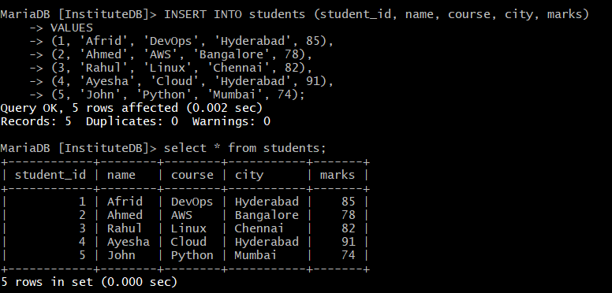Result
Successfully created the InstituteDB database, created the students table, inserted dummy records, updated a record, and verified the data.

- Take the backup of dummy data on EC2.

Objective
To create a backup of a MariaDB database running on an EC2 instance and store the backup as an SQL file on the EC2 server.

Procedure

1. Create Database Backup
Used the mariadb-dump utility to export the database into an SQL file.
sudo mariadb-dump -u root InstituteDB > InstituteDB_backup.sql

2. Verify Backup File
Checked whether the backup file was created successfully:
ls -lh InstituteDB_backup.sql
Output:
-rw-r--r--. 1 ec2-user ec2-user 2.4K Sep 16 10:43 InstituteDB_backup.sql

3. Backup File
The backup was stored on the EC2 instance as:
InstituteDB_backup.sql

The SQL dump contains the database structure and data and can later be used to restore or migrate the database.

Result
Successfully created and verified a MariaDB database backup in SQL dump format on the EC2 instance.

- Launch MariaDB RDS instance.

Objective
Launch an Amazon RDS MariaDB database in AWS using a private subnet configuration so that the database can later receive the MariaDB database migrated from the EC2 instance.

1. RDS Configuration

AWS Region
US East (N. Virginia)
Region: us-east-1

Creation Method
Full configuration

Template
Free Tier
The Free Tier template was selected for practice to minimize cost, subject to AWS account eligibility and current Free Tier terms.

Database Engine
MariaDB

Engine Version
MariaDB 11.8.8

DB Instance Identifier
rds-lab-mariadb

Master Username
admin
A separate master user was used for the RDS database.

2. Instance Configuration

DB Instance Class
db.t4g.micro
Configuration shown:
2 vCPU
1 GiB RAM

Storage
Storage type: General Purpose SSD (gp2)
Allocated storage: 20 GiB

Availability & Durability
Do not create a standby instance
Multi-AZ standby was not enabled because Multi-AZ configuration is planned for Task 8.

3. Network Configuration
The RDS database was placed inside the dedicated lab VPC.

VPC
RDS-Lab-VPC
CIDR: 10.0.0.0/16

DB Subnet Group
rds-lab-db-subnet-group
The subnet group contains two private subnets in different Availability Zones:
RDS-Lab-Private-Subnet-1
10.0.11.0/24
us-east-1a

RDS-Lab-Private-Subnet-2
10.0.12.0/24
us-east-1b

Public Access
No
The RDS database is not directly accessible from the Internet.

4. Security Group
Existing security group:
RDS-Lab-RDS-SG
Inbound rule:
Type: MySQL/Aurora
Protocol: TCP
Port: 3306
Source: RDS-Lab-EC2-SG
This allows the EC2 instance to connect to the RDS database on port 3306 without exposing the database publicly.

5. Additional Configuration

Database Port
3306
Port 3306 is the standard port used by MariaDB/MySQL.

RDS Proxy
Disabled

Certificate
Default RDS CA certificate
rds-ca-rsa2048-g1

Encryption
Enabled

Automated Backup
Enabled

Delete Protection
Disabled
Enhanced Monitoring and additional log exports were not enabled for this basic practice lab.

6. Architecture
Internet
|
↓
Internet Gateway
|
↓
Public Subnet
|
↓
EC2 - MariaDB
RDS-Lab-MariaDB-EC2
|
TCP 3306
|
↓
RDS-Lab-RDS-SG
|
↓
MariaDB RDS Instance
rds-lab-mariadb
|
↓
Private Subnets
10.0.11.0/24
10.0.12.0/24

7. Why RDS Was Made Private
The RDS instance was configured with:
Public access = No
This means users on the Internet cannot directly connect to the database.
Only resources allowed by the RDS security group can connect.
For this lab:
EC2 Security Group
↓
TCP 3306
↓
RDS Security Group
↓
MariaDB RDS
This is safer than allowing:
0.0.0.0/0 → TCP 3306

8. Verification
After creating the RDS instance, the RDS console showed:
Status: Available
This confirms that the MariaDB RDS instance was successfully created and is ready for connections.

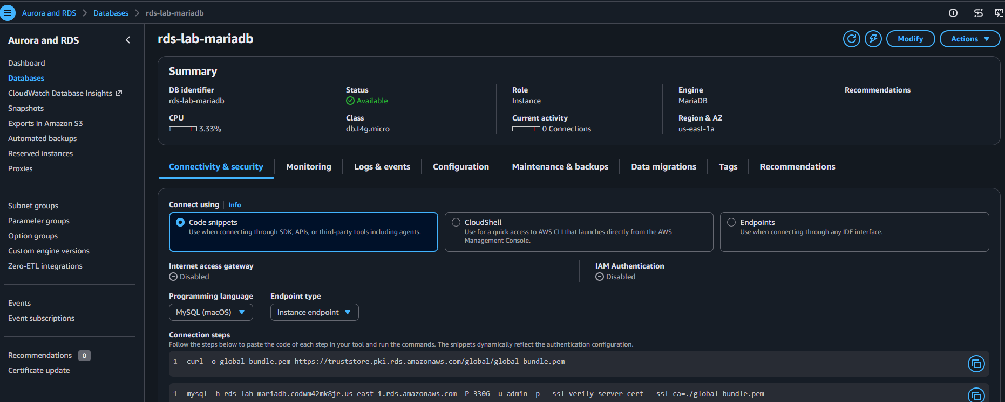

Result
A MariaDB RDS instance was launched in the dedicated RDS-Lab-VPC using private subnets and secured so that the EC2 instance can communicate with RDS through TCP port 3306.

- Migrate database from EC2 to RDS.

Objective
Migrate the InstituteDB database from EC2 MariaDB to MariaDB RDS.

1. RDS Endpoint
rds-lab-mariadb.codwm42mk8jr.us-east-1.rds.amazonaws.com

2. Test EC2 → RDS Connection
mariadb -h rds-lab-mariadb.codwm42mk8jr.us-east-1.rds.amazonaws.com -u admin -p
Enter the RDS password.

3. Create Database on RDS
CREATE DATABASE INstituteDB;
Verify:
SHOW DATABASES;

4. Main Migration Command
From the EC2 Linux shell:
mariadb -h rds-lab-mariadb.codwm42mk8jr.us-east-1.rds.amazonaws.com -u admin -p INstituteDB < InstituteDB_backup.sql

Command Explanation
- -h → RDS endpoint
- -u admin → RDS username
- -p → asks for password
- INstituteDB → target database
- < InstituteDB_backup.sql → imports the SQL backup into RDS

5. Verify Migration
Connect to RDS:
mariadb -h rds-lab-mariadb.codwm42mk8jr.us-east-1.rds.amazonaws.com -u admin -p INstituteDB

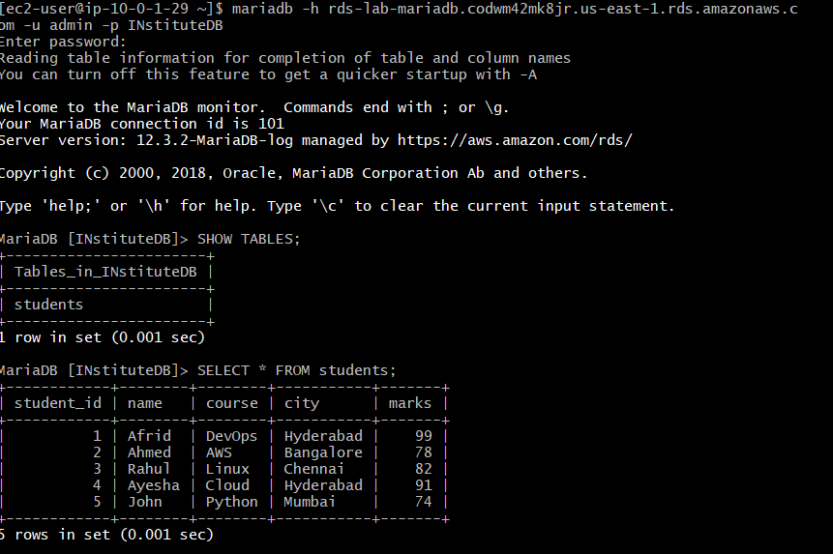

Check tables:
SHOW TABLES;
Result:
students
Check data:
SELECT * FROM students;
The migrated student data was displayed successfully.

Result
✅ EC2 MariaDB → MariaDB RDS migration completed successfully.
Key concept: mariadb-dump creates the SQL backup, and the mariadb client imports that backup into RDS.
- Install MySQL DB on EC2.

Objective
Install and configure MySQL Server on a new EC2 instance.

EC2
Name: RDS-Lab-MySQL-EC2
AMI: Amazon Linux 2023
Instance: t3.micro
Subnet: RDS-Lab-Public-Subnet-2

1. Add MySQL Repository
sudo dnf install https://dev.mysql.com/get/mysql84-community-release-el9-1.noarch.rpm -y

2. Install MySQL
sudo dnf install mysql-community-server -y

3. Start MySQL
sudo systemctl start mysqld

4. Enable MySQL at Boot
sudo systemctl enable mysqld

5. Verify Status
sudo systemctl status mysqld
Result:
Active: active (running)

6. Verify Version
mysql --version
Result:
MySQL 8.4.11

Result
✅ MySQL 8.4.11 successfully installed and running on EC2.
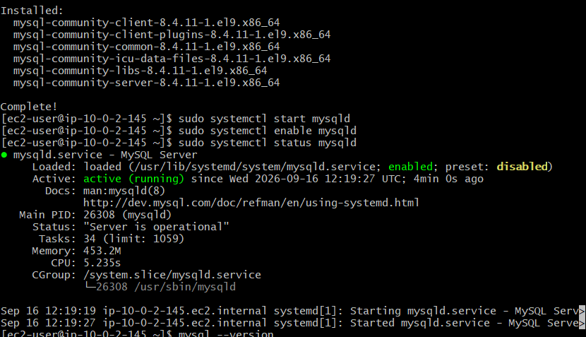

- Launch MySQL RDS image.

Objective
Launch a MySQL database on Amazon RDS for the lab.

RDS Configuration
Region: us-east-1
Engine: MySQL
Version: MySQL 8.4.x
DB Identifier: rds-lab-mysql
Master Username: admin
Instance: db.t4g.micro
Storage: 20 GiB General Purpose SSD

Connectivity
VPC: RDS-Lab-VPC
DB Subnet Group: rds-lab-db-subnet-group
Public Access: No
Security Group: RDS-Lab-RDS-SG
Port: 3306

Availability
Multi-AZ Standby: Not enabled
Status: Available
Multi-AZ will be configured separately in Task 8.

Architecture
MySQL EC2
|
| TCP 3306
↓
RDS Security Group
|
↓
MySQL RDS
(Private Subnets)

Result
✅ MySQL RDS instance successfully launched and reached Available status.

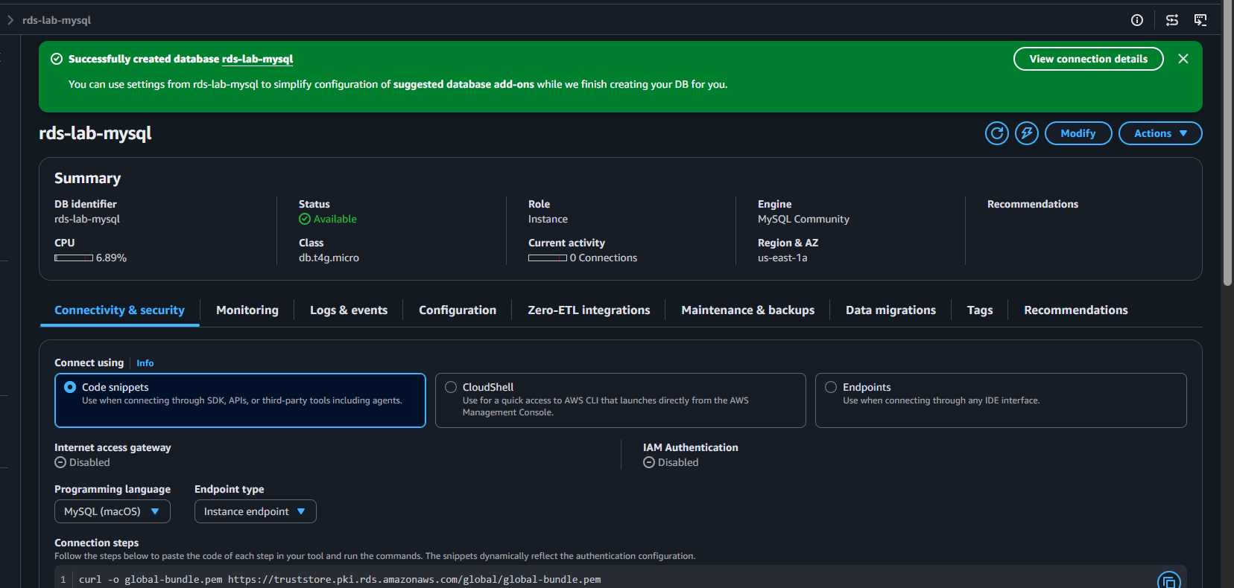

- Configure Multi-AZ.

Objective
Configure Multi-AZ deployment for the MySQL RDS database.

Attempted Configuration
In RDS → MySQL → Availability & durability, the following options were shown:
- Multi-AZ DB cluster — 3 instances
- Multi-AZ DB instance — 2 instances
- Single-AZ DB instance — 1 instance

Result
Multi-AZ options were not selectable.
Current deployment: Single-AZ
Multi-AZ: Not configured
Reason: AWS Free Plan / Free Tier limitation
The Free Tier configuration only allowed the Single-AZ deployment for this lab.

Conclusion
❌ Multi-AZ could not be configured under the current Free Plan.

Not eligible for multi AZ because of using free tier:
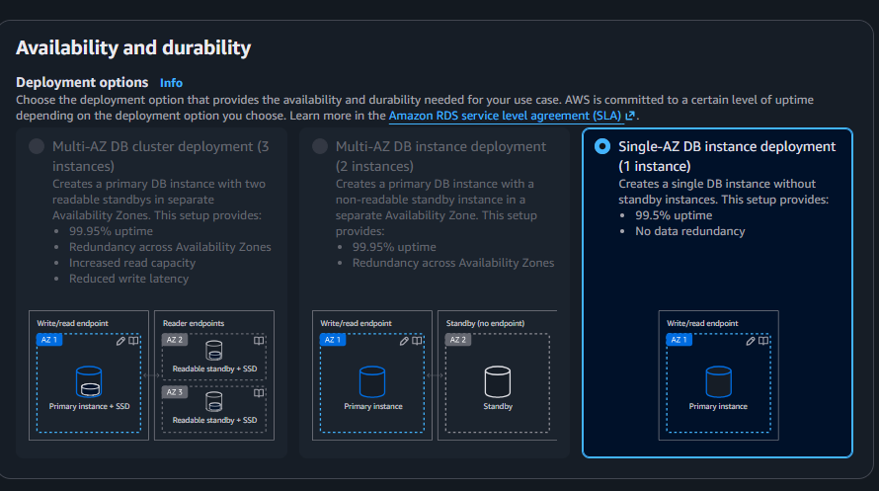

- Take backup of DB and restore the DB.

Objective
Create a manual backup of an RDS database and restore it as a new RDS instance.

Steps
- Open AWS RDS → Databases.
- Select the database rds-lab-mysql.
- Choose Actions → Take snapshot.
- Enter snapshot name:
rds-lab-mysql-backup
- Wait until the snapshot status becomes Available.
- Select the snapshot → Actions → Restore snapshot.
- Configure the restored database:
  - DB identifier: rds-lab-mysql-restored
  - Instance: db.t3.micro
  - VPC: RDS-Lab-VPC
  - DB subnet group: rds-lab-db-subnet-group
  - Public access: No
  - Security group: RDS-Lab-RDS-SG
  - Deployment: Single-AZ
- Create the restored database.
- Wait until rds-lab-mysql-restored becomes Available.
- Verify the restored database and capture a screenshot.

Result
- Manual snapshot rds-lab-mysql-backup created successfully.
- Database restored as rds-lab-mysql-restored and reached Available status.
- Restored instance was later deleted to free the Free Plan RDS instance slot.
Key Concept:
Snapshot → Backup of RDS database
Restore → Creates a new RDS instance from the snapshot

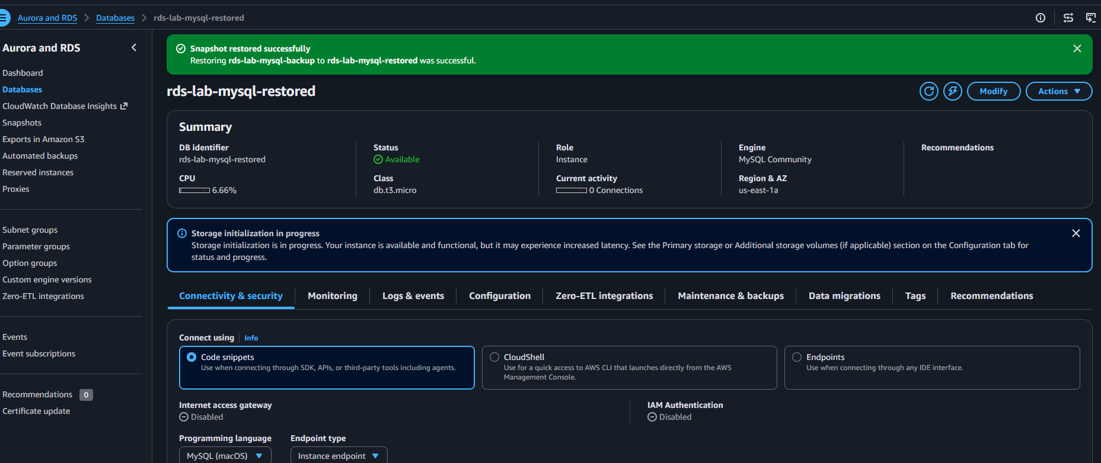

- Create read replica.

Objective
Create a Read Replica of the MySQL RDS database for read scalability and redundancy.

Source RDS
DB Instance: rds-lab-mysql
Engine: MySQL
Region: us-east-1

Read Replica Configuration
DB Identifier: rds-lab-mysql-replica
Instance: db.t4g.micro
Region: US East (N. Virginia)
Deployment: Single-AZ
DB Subnet Group: rds-lab-db-subnet-group
Public Access: No
Security Group: RDS-Lab-RDS-SG
Port: 3306

Architecture
MySQL RDS
rds-lab-mysql
|
Replication
↓
MySQL Read Replica
rds-lab-mysql-replica

Important
A Read Replica maintains a replicated copy of the source database and can be used for read workloads.
It is different from Multi-AZ:
Read Replica → Read scaling
Multi-AZ → High availability/failover

Result
✅ Read Replica successfully created from rds-lab-mysql.

